|  |  |  |  |
| --- | --- | --- | --- |
| **Course Code:** | **ECE1002** | **Course Name:** | **Semiconductor Devices and Circuits Lab** |
| **Faculty In – Charge:** | **Dr. Pradeep Naryanan. S.** | **Department:** | **SENSE** |
| **Name of the Student:** | **Aryan Pandey** | **Registration Number:** | **20BLC1087** |
| **Experiment No.:** | **7** | **Date of Experiment:** | **26.04.2021** |
| **Name of the Experiment:** | **DESIGN AND VERIFIY THE CIRCUIT TO MEASURE AND PLOT THE INPUT / OUTPUT CHARACTERISTICS OF A TRANSISTOR UNDER COMMON BASE / COMMON EMITTER / COMMON EMITTER CONFIGURATIONS** | | |

**OBJECTIVE:**

To design and verify the behaviour of transistor constructed in Common Base / Common Emitter / Common Collector configuration using LT Spice Simulator and observe its characteristics.

**TOOLS:**

LTSPICE XVII Simulator.

**THEORY**

**BIPOLAR JUNCTION TRANSISTOR:**

A bipolar junction transistor is a type of transistor that uses both electrons and electron holes as charge carriers. In contrast, a unipolar transistor, such as a field-effect transistor, uses only one kind of charge carrier.

If we now join together two individual signal diodes back-to-back, this will give us two PN-junctions connected together in series which would share a common Positive (P) or Negative (N) terminal. The fusion of these two diodes produces a three layer, two junction, three terminal device forming the basis of a Bipolar Junction Transistor, or BJT for short.

Transistors are three terminal active devices made from different semiconductor materials that can act as either an insulator or a conductor by the application of a small signal voltage.

The transistor’s ability to change between these two states enables it to have two basic functions: “switching” (digital electronics) or “amplification” (analogue electronics). Then bipolar transistors have the ability to operate within three different regions:

* Active Region - The transistor operates as an amplifier and IC = β*IB
* Saturation - The transistor is “Fully-ON” operating as a switch and IC = I(saturation)
* Cut-off   –   the transistor is “Fully-OFF” operating as a switch and IC = 0

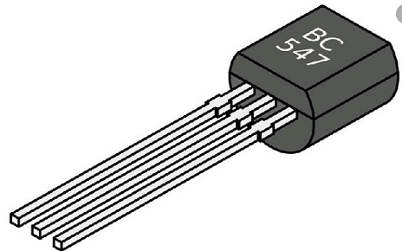

A Typical Bipolar Transistor

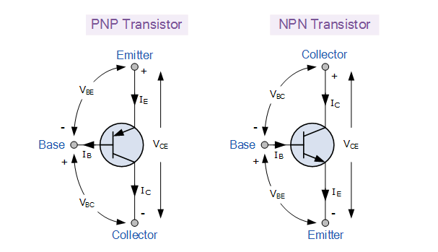

**NPN TRANSISTOR: -**

### NPN BJT: -

### In NPN BJT, p-type semiconductor is sandwiched between the two n-type semiconductors. The two n-type semiconductors act as emitter and collector respectively while the p-type semiconductor acts as a base. This is shown in the figure below.

### 

### Current entering the emitter, base, and collector has the sign convention of positive while the current that leaves the transistor has the sign convention of negative.

**PNP TRANSISTOR: -**

### PNP BJT: -

In PNP BJT, the n-type semiconductor is sandwiched between the two p-type semiconductors. The two p-type semiconductors act as emitter and collector respectively while the n-type semiconductor acts as a base. This is shown in the figure below.

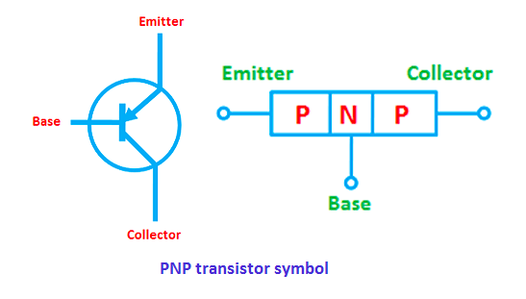

The current enters the transistor through the emitter such that the emitter-base junction is forward biased and the collector-base junction is reverse biased.

**COMMON BASE CONFIGURATION (NPN TRANSISTOR): -**

### Common Base Amplifier using an NPN Transistor: -

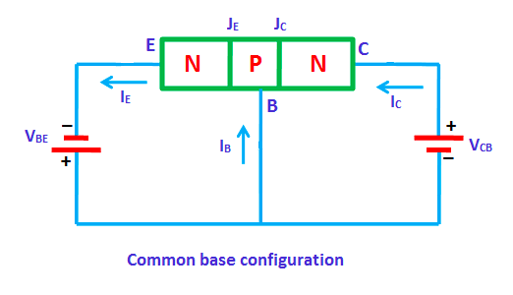

Then we can see from the basic common base configuration that the input variables relate to the emitter current IE and the base-emitter voltage, VBE, while the output variables relate to the collector current IC and the collector-base voltage, VCB.

**COMMON EMITTER CONFIGIRATION (NPN TRANSISTOR):**

### The Common Emitter Amplifier Circuit: -

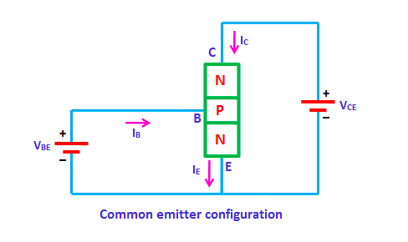

The single stage common emitter amplifier circuit shown above uses what is commonly called “Voltage Divider Biasing”. This type of biasing arrangement uses two resistors as a potential divider network across the supply with their centre point supplying the required Base bias voltage to the transistor. Voltage divider biasing is commonly used in the design of bipolar transistor amplifier circuits.

**COMMON COLLECTOR CONFIGIRATION (NPN TRANSISTOR):**

### Common Collector Amplifier using an NPN Transistor: -

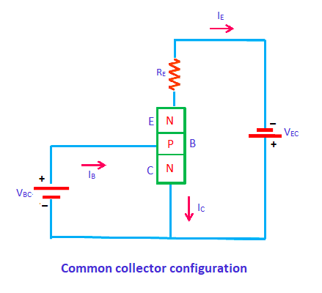

Resistors R1 and R2 form a simple voltage divider network used to bias the NPN transistor into conduction. Since this voltage divider lightly loads the transistor, the base voltage, VB can be easily calculated by using the simple voltage divider formula as shown.

**PROCEDURE**

**FOLLOW THE SAME STEPS FOR ALL COMMON BASE ,COMMON EMITTER AND COMMON COLLECTOR: -**

Common Emitter: -

Start Simulation: -

Open LT Spice and start a new schematic.

DRAW TRANSISTOR AND SET VCC AND VBB VALUES: -

* We are using transistor “BC547B”. “VBE” is the base emitter voltage applied between base and the emitter .
* “VCE” is the collector emitter voltage applied between collector and emitter.
* Here, the emitter terminal is common to both input and output. So, it is called common emitter configuration.
* “R1” is the input resistance having a value of 100K ohm and “R2” is the output resistance  having a value of 1KΩ.
* “IB”  is the base current and “IC” is the collector current. Set “VBB” to 0 VT in the beginning and “VCC” to 0V.

DC SWEEP ANALYSIS: -

1. Now perform DC sweep analysis In LT Spice to plot input characteristics.
2. Now, click on the simulate button and select simulation command. Then from the pop-up window select “DC Sweep”.
3. Here you need to select the option “First Source” since we are plotting the input characteristics. So, enter the values for the below parameters. Refer the below screen.
4. Under First Source: -

* Name of First Voltage Source - VBB
* Type of Sweep - Linear
* Start Value - 0
* Stop Value -2
* Increment - 0.01

1. Under Source 2: -

* Name of First Voltage Source - VCC
* Type of Sweep - Linear
* Start Value - 2
* Stop Value - 6
* Increment - 2

1. Now click OK and click “run”. Then the screen will be divided into two parts (circuit & graphic part) as seen in the below screen shot.
2. In the above figure, x-axis is “VBE” with values varying from 0 to 1V. For plotting input characteristic, measure the “IB” and plot it on y-axis. In order to do it, right click on the graphic plane and select “Add Trace” and select “IB” from the list which is shown in figure.
3. Now, Click OK .Then we will get the input characteristic. You can see the plot of input characteristics in the below diagram.

SIMILARLY FOR INPUT CHARACTERSTICS WE SHOULD ARRANGE IN THE FOLLOWING WAY: -

Common Base: -

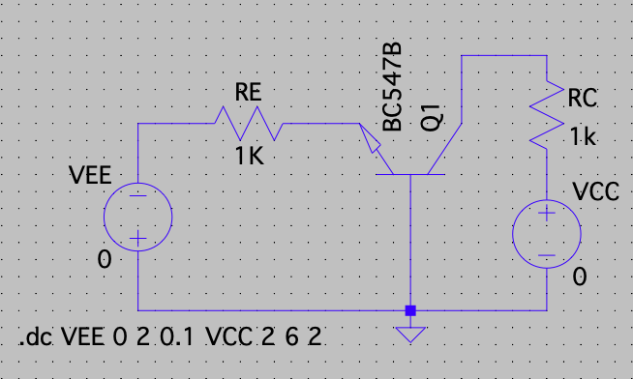

Common Emitter: -

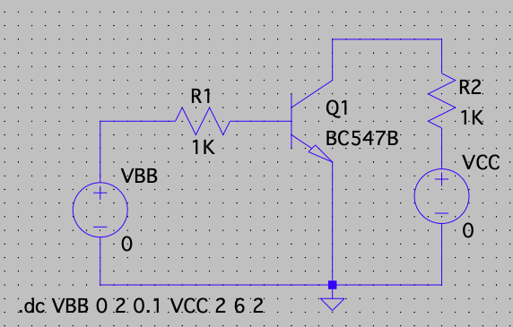

Common Collector: -

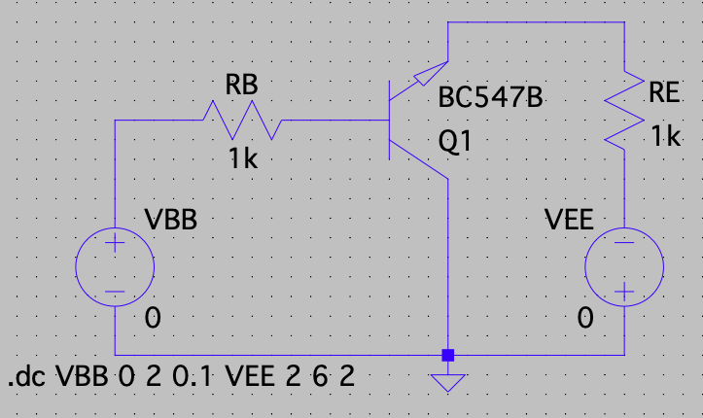

**OUTPUT CHARACTERISTICS**

* Output characteristics can be plotted on a graph between output voltage (VCE)  and output current (IC) for a constant base current(IB).The circuit diagram for plotting Output characteristics is shown below.
* First, set both voltage source (VBE & VCE) to zero. For plotting output characteristics, change the collector emitter voltage from 0 to 10V and change the base emitter voltage from 0 to 1V. Observe the collector current “IC”. Now perform DC sweep analysis In LT Spice to plot output characteristics.
* Now, click on the simulate button and select simulation command. Then from the pop-up window select “DC Sweep”. Here you need to select the option “First Source” since we are plotting the output characteristics.
* So, enter the values for the below parameters. Refer the below screen.

1. Name of First Voltage Source - VCC
2. Type of Sweep - Linear
3. Start Value - 0
4. Stop Value - 10
5. Increment - 0.1

* The second voltage to be sweep is VBB: -

1. Name of Second Voltage Source - VBB
2. Type of Sweep - Linear
3. Start Value - 0.5
4. Stop Value - 1
5. Increment - 0.1

* Now click on “OK” button and click “Run”. Then the screen will be divided in to  two parts (circuit & graphic part) as seen in the below screen shot. In the below figure , x-axis is “VCE” having value is vary from 0 to 10V.
* For plotting output characteristic measure the “IC” and plot it on y-axis. In order to do this, right click on the graphic plane select “add trace” and select “IC” from the list.
* Click OK and we will get the output characteristic. Refer the below screen shot.

Common Base: -

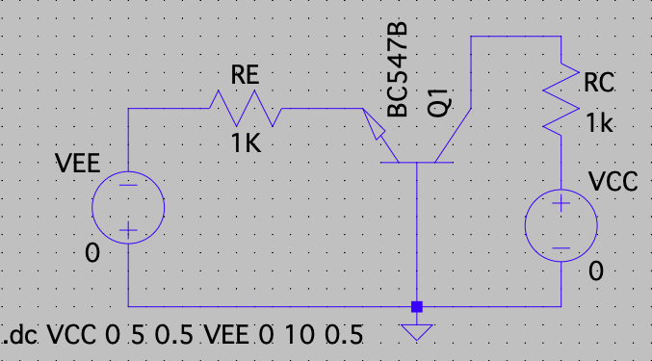

Common Emitter: -

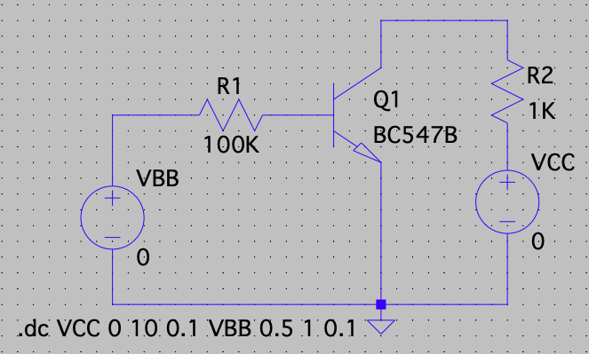

Common Collector: -

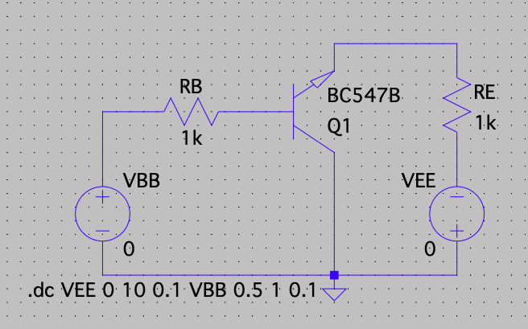

(A) **Verification Common Base Configuration**

**(NPN Transistor): -**

* Input Characteristics: -

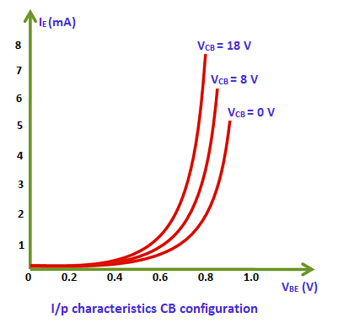

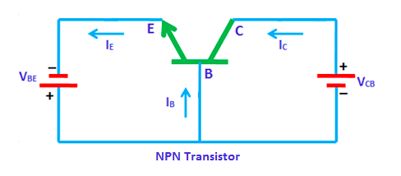

Components Required: -

* + Voltmeter
  + NPN Transistor
  + Resistors
  + Wires
  + Ground

Logic Diagram: -

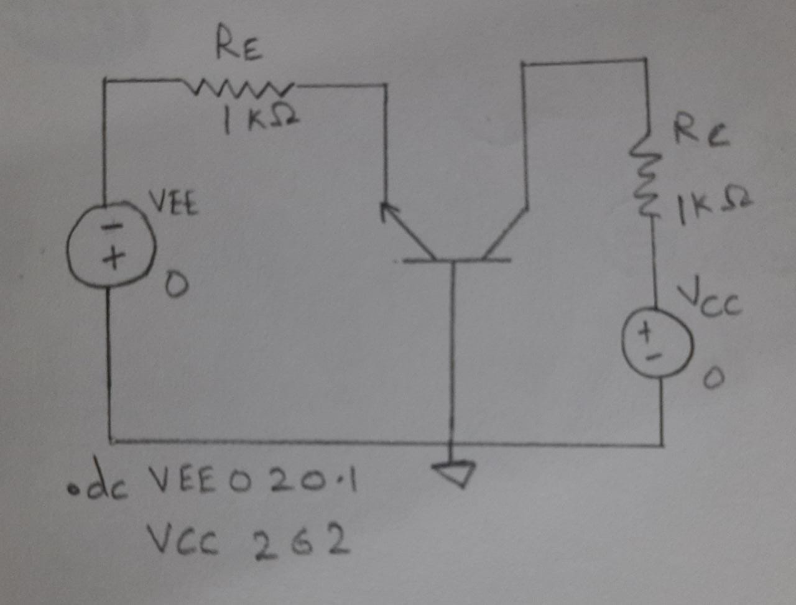

Simulator Diagram - Schematic: -



Output Waveform: -

Contains Multiple Lines: -

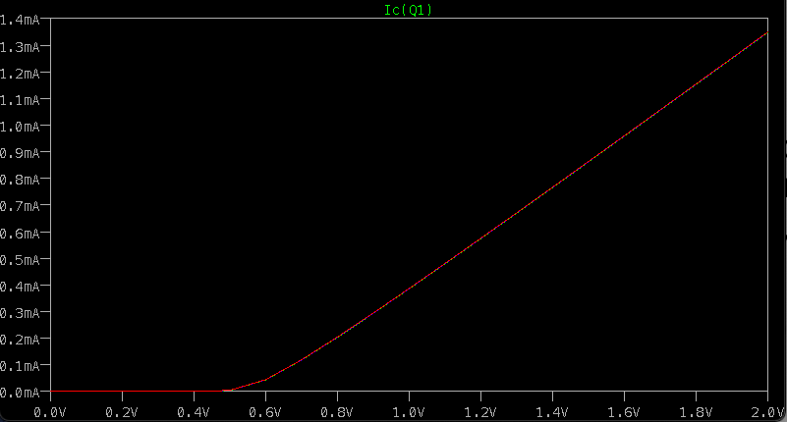

* Output Characteristics: -

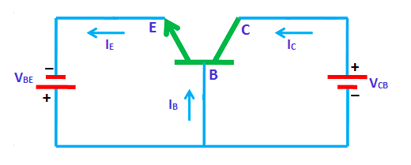

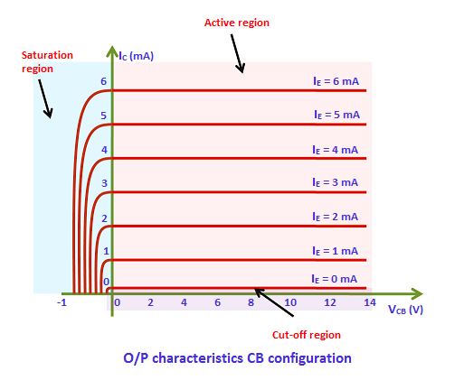

Components Required: -

* + Voltmeter
  + NPN transistor
  + Resistors
  + Wires
  + Ground

Logic Diagram: -

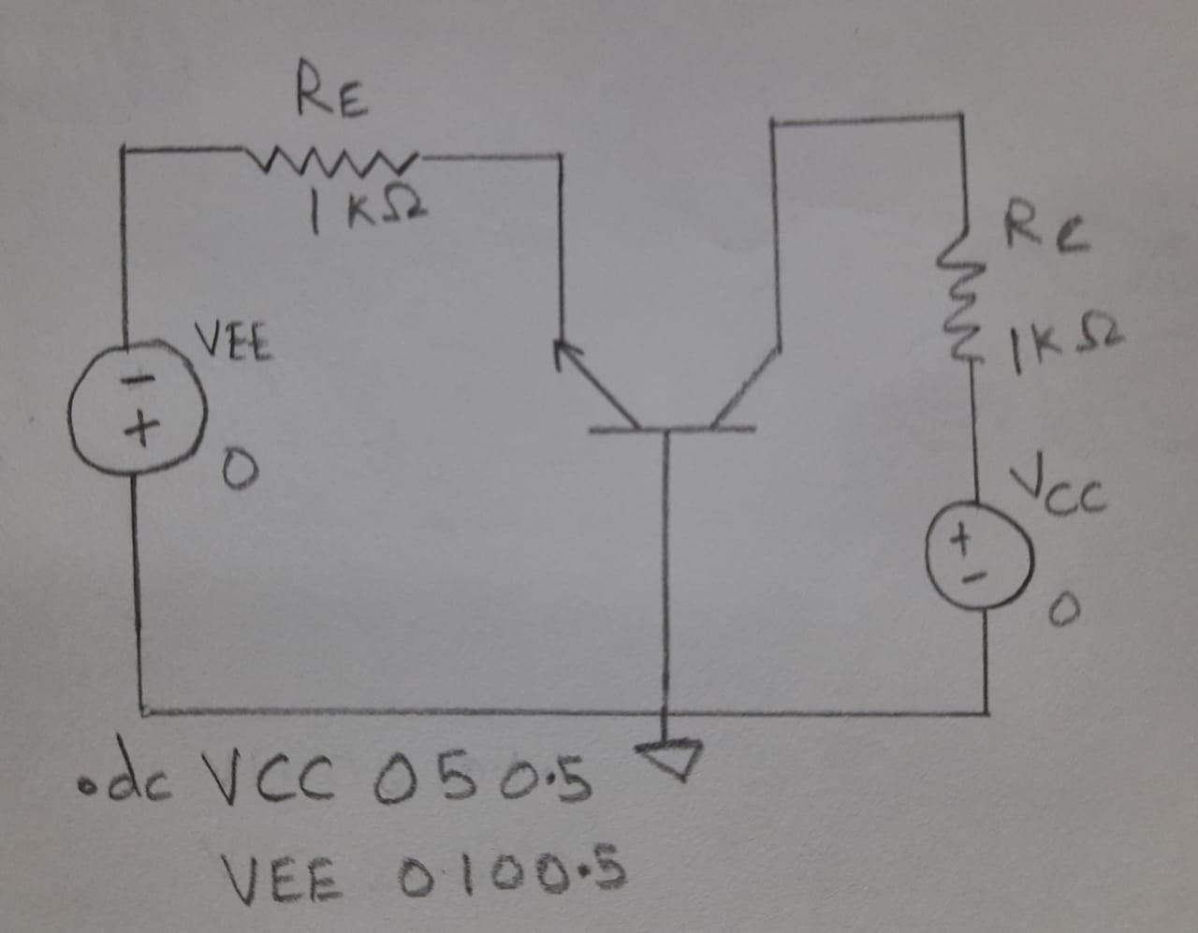

Simulator Diagram - Schematic: -



Output Waveform: -

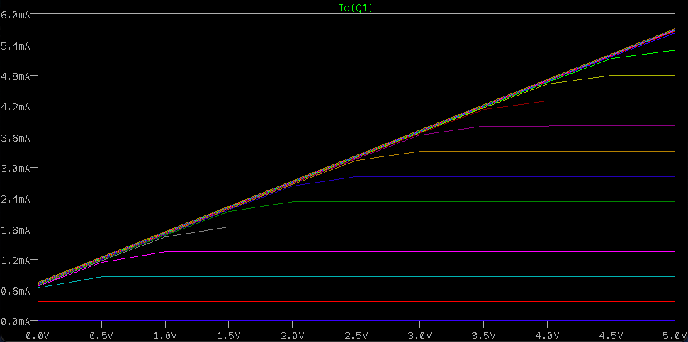

(B) **Verification of Common Emitter Configuration**

**(NPN Transistor): -**

* Input Characteristics: -

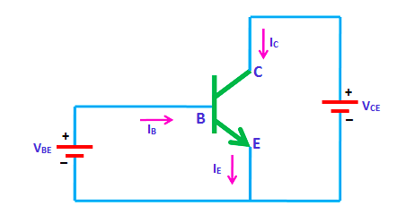

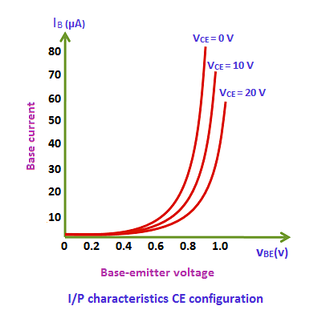

Components Required: -

* + Voltmeter
  + NPN transistor
  + Resistors
  + Wires
  + Ground

Logic Diagram: -

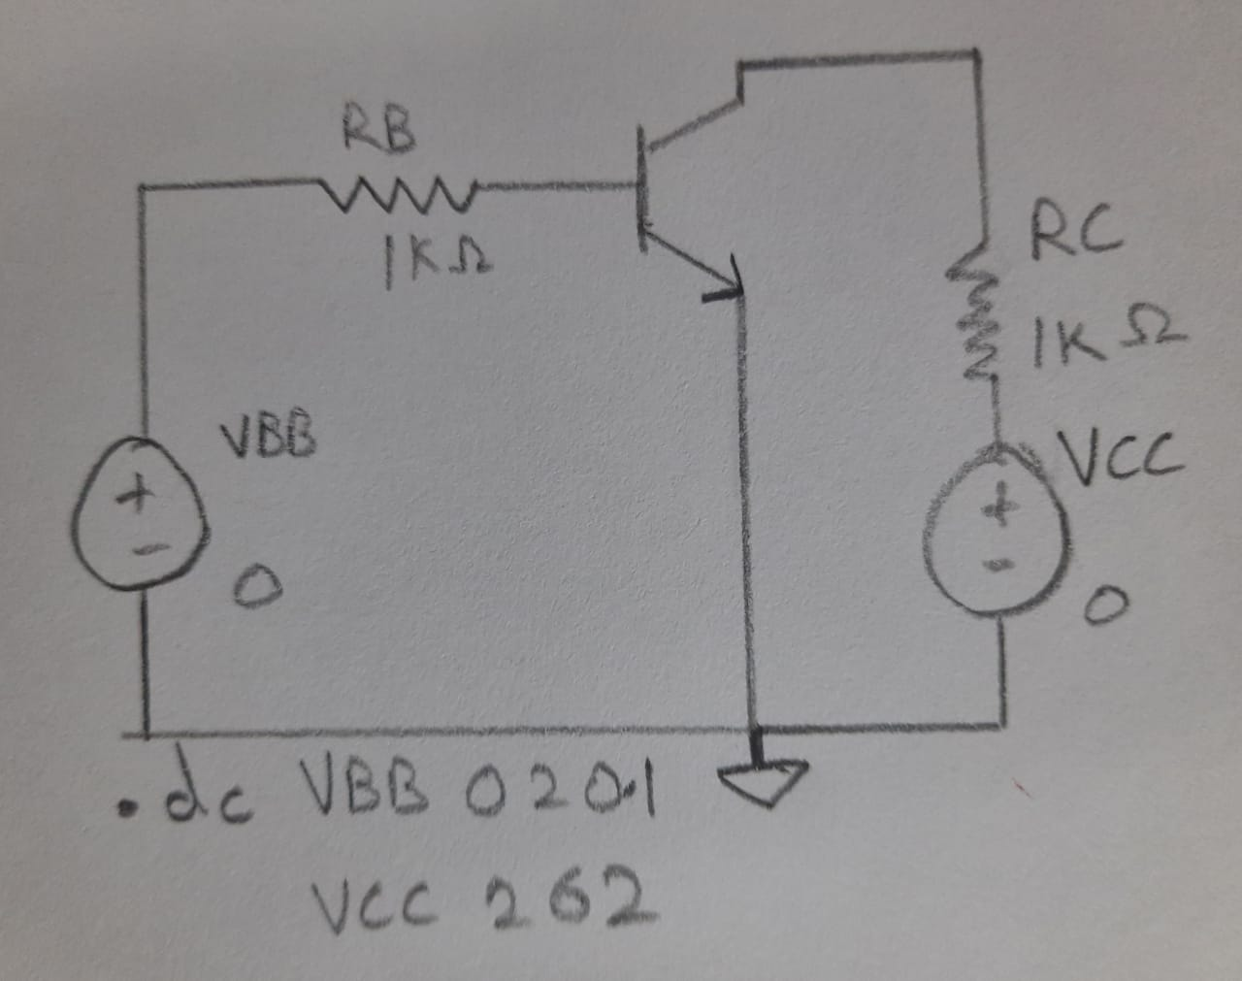

Simulator Diagram - Schematic: -



Output Waveform: -

Contains Multiple Lines: -

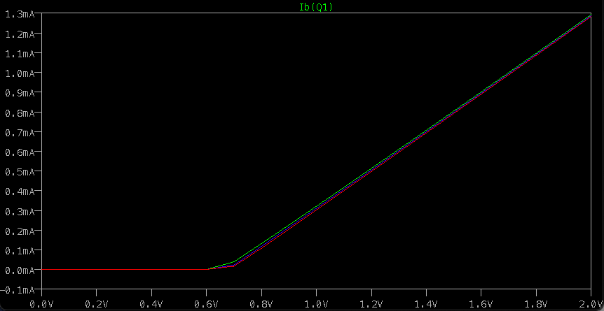

* Output Characteristics: -

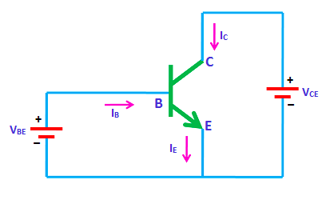

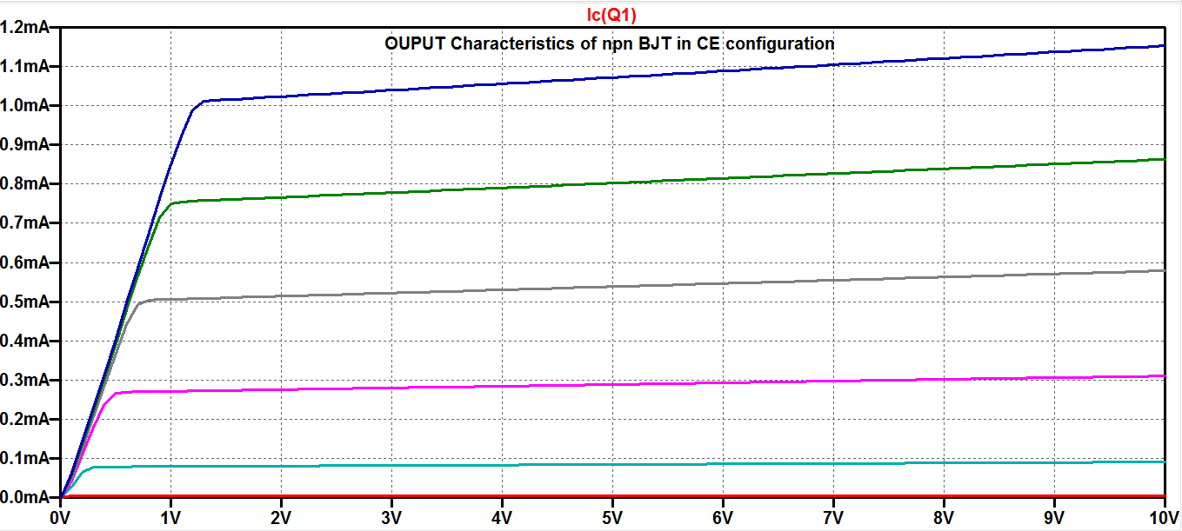

Components Required: -

* + Voltmeter
  + NPN transistor
  + Resistors
  + Wires
  + Ground

Logic Diagram: -

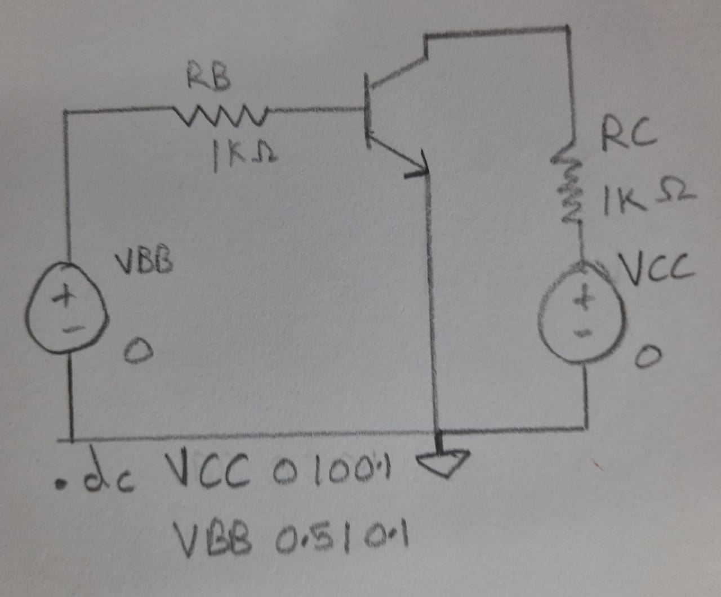

Simulator Diagram – Schematic: -



**Output Waveform: -**

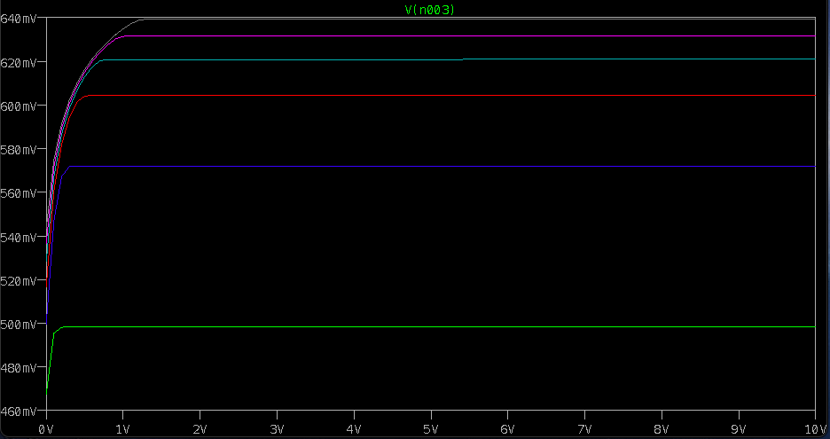

**(C) Verification of Common Collector Configuration**

**(NPN Transistor): -**

* Input Characteristics: -

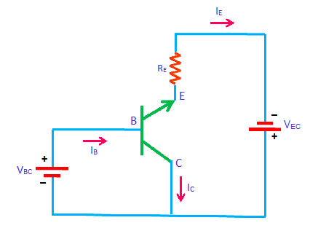

The configuration in which the collector is common between emitter and base is known as CC configuration. In CC configuration, the input circuit is connected between emitter and base and the output is taken from the collector and emitter.

Components Required: -

* + Voltmeter
  + NPN transistor
  + Resistors
  + Wires
  + Ground

Logic Diagram: -

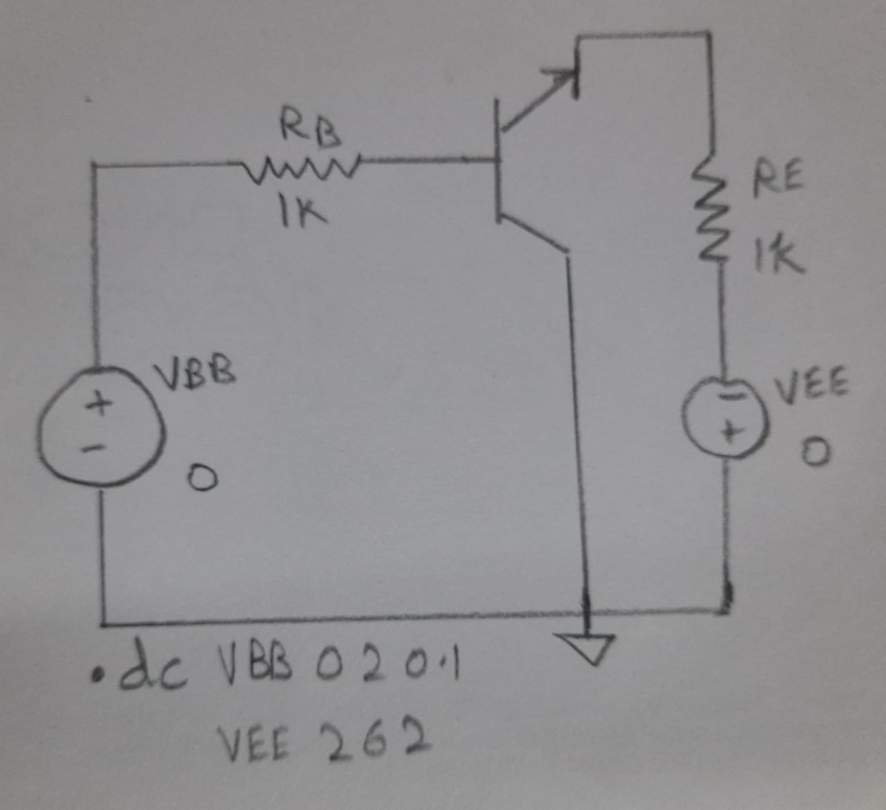

Simulator Diagram - Schematic: -



**Output Waveform: -**

**With Several Lines: -**

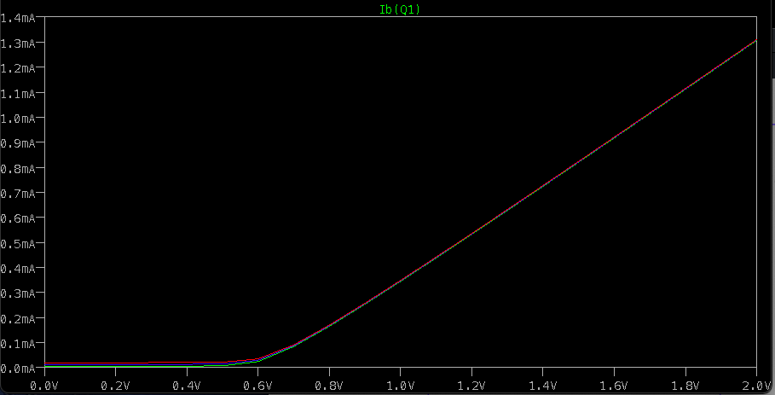

* OUTPUT CHARACTERISTICS: -

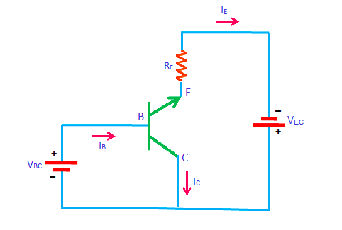

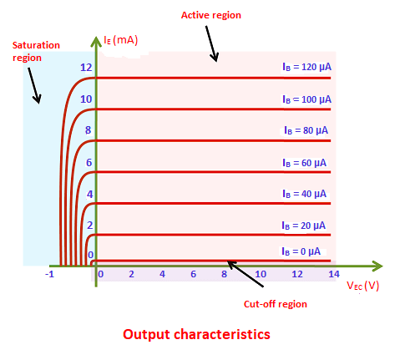

Components Required: -

* + Voltmeter
  + NPN transistor
  + Resistors
  + Wires
  + Ground

Logic Diagram: -

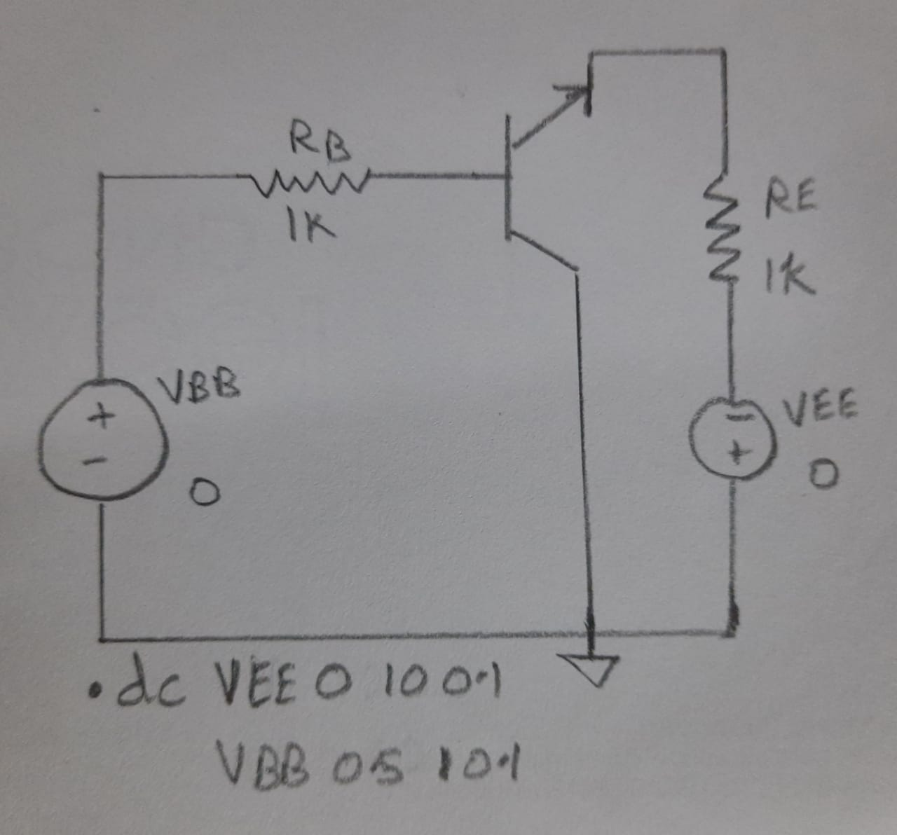

Simulator Diagram – Schematic: -



Output Waveform: -

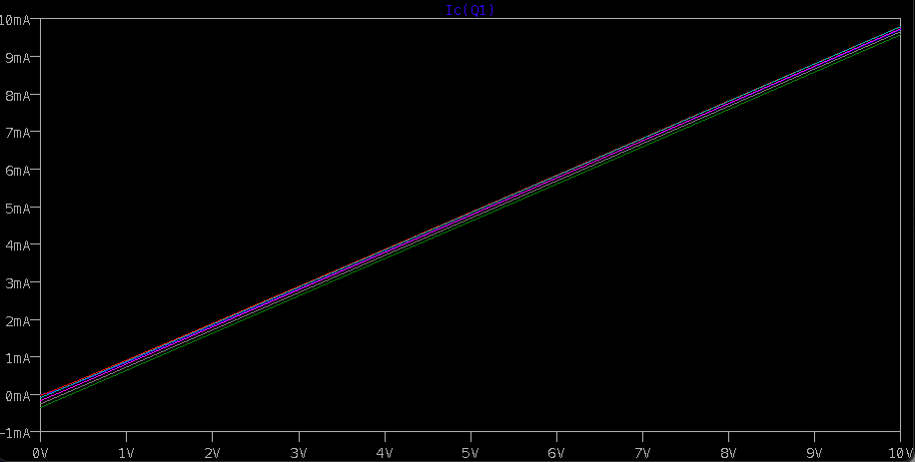

**INFERENCE**

**Common Base: -**

The input characteristics describe the relationship between input current (IE) and the input voltage (VBE).

The input current or emitter current (IE) is taken along the y-axis (vertical line) and the input voltage (VBE)is taken along the x-axis (horizontal line).

To determine the input characteristics, the output voltage VCB (collector-base voltage) is kept constant at zero volts and the input voltage VBE is increased from zero volts to different voltage levels. For each voltage level of the input voltage (VBE), the input current (IE) is recorded on a paper or in any other form.

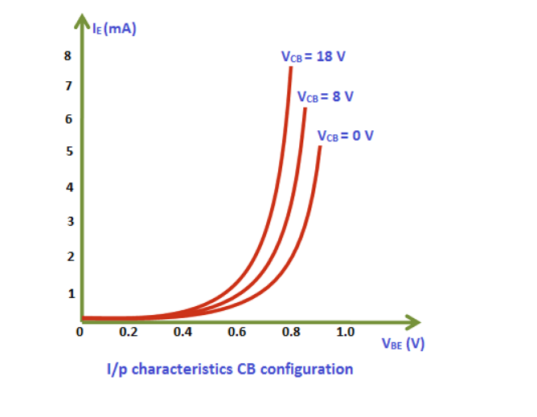

A curve is then drawn between input current IE and input voltage VBE at constant output voltage VCB(0 volts).

Next, the output voltage (VCB) is increased from zero volts to a certain voltage level (8 volts) and kept constant at 8 volts. While increasing the output voltage (VCB), the input voltage (VBE) is kept constant at zero volts. After we kept the output voltage (VCB) constant at 8 volts, the input voltage VBE is increased from zero volts to different voltage levels. For each voltage level of the input voltage (VBE), the input current (IE) is recorded on a paper or in any other form.

The output characteristics describe the relationship between output current (IC) and the output voltage (VCB).

The output current or collector current (IC) is taken along the y-axis (vertical line) and the output voltage (VCB)is taken along the x-axis (horizontal line).

To determine the output characteristics, the input current or emitter current IE is kept constant at zero mA and the output voltage VCB is increased from zero volts to different voltage levels. For each voltage level of the output voltage VCB, the output current (IC) is recorded.

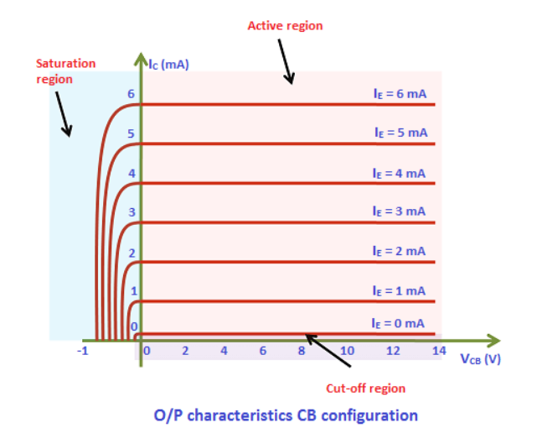

**Common Emitter: -**

The input characteristics describe the relationship between input current or base current (IB) and input voltage or base-emitter voltage (VBE).

First, draw a vertical line and a horizontal line. The vertical line represents y-axis and horizontal line represents x-axis. The input current or base current (IB) is taken along y-axis (vertical line) and the input voltage (VBE)is taken along x-axis (horizontal line).

To determine the input characteristics, the output voltage VCE is kept constant at zero volts and the input voltage VBE is increased from zero volts to different voltage levels. For each voltage level of input voltage (VBE), the corresponding input current (IB) is recorded.

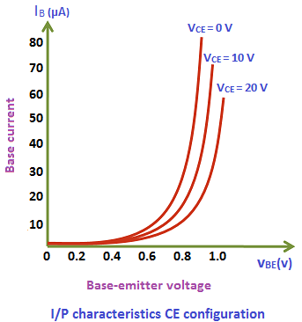

A curve is then drawn between input current IB and input voltage VBE at constant output voltage VCE(0 volts).

Next, the output voltage (VCE) is increased from zero volts to certain voltage level (10 volts) and the output voltage (VCE) is kept constant at 10 volts. While increasing the output voltage (VCE), the input voltage (VBE) is kept constant at zero volts.

After we kept the output voltage (VCE) constant at 10 volts, the input voltage VBE is increased from zero volts to different voltage levels. For each voltage level of input voltage (VBE), the corresponding input current (IB) is recorded.

## **Output characteristics: -**

The output characteristics describe the relationship between output current (IC) and output voltage (VCE).

First, draw a vertical line and a horizontal line. The vertical line represents y-axis and horizontal line represents x-axis. The output current or collector current (IC) is taken along y-axis (vertical line) and the output voltage (VCE)is taken along x-axis (horizontal line).

To determine the output characteristics, the input current or base current IB is kept constant at 0 μA and the output voltage VCE is increased from zero volts to different voltage levels. For each level of output voltage, the corresponding output current (IC) is recorded.

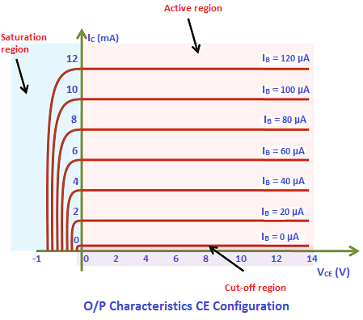

Common Collector: -

The input characteristics describe the relationship between input current or base current (IB) and input voltage or base-collector voltage (VBC).

First, draw a vertical line and a horizontal line. The vertical line represents y-axis and horizontal line represents x-ax

The input current or base current (IB) is taken along y-axis (vertical line) and the input voltage or base-collector voltage (VBC) is taken along x-axis (horizontal line).

To determine the input characteristics, the output voltage VEC is kept constant at 3V and the input voltage VBC is increased from zero volts to different voltage levels. For each level of input voltage VBC, the corresponding input current IB is noted. A curve is then drawn between input current IB and input voltage VBC at constant output voltage VEC (3V).

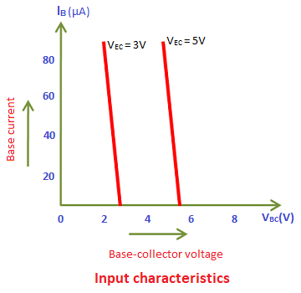

Next, the output voltage VEC is increased from 3V to different voltage level, say for example 5V and then kept constant at 5V. While increasing the output voltage VEC, the input voltage VBC is kept constant at zero volts.

The output characteristics describe the relationship between output current or emitter current (IE) and output voltage or emitter-collector voltage (VEC).

First, draw a vertical line and a horizontal line. The vertical line represents y-axis and horizontal line represents x-axis.

The output current or emitter current (IE) is taken along y-axis (vertical line) and the output voltage or emitter-collector voltage (VEC) is taken along x-axis (horizontal line).

To determine the output characteristics, the input current IB is kept constant at zero micro amperes and the output voltage VEC is increased from zero volts to different voltage levels. For each level of output voltage VEC, the corresponding output current IE is noted. A curve is then drawn between output current IE and output voltage VEC at constant input current IB (0 μA).

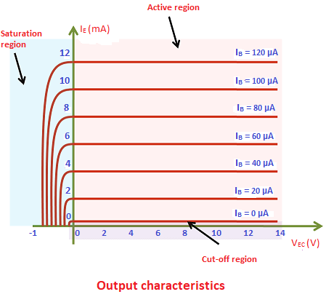

Next, the input current (IB) is increased from 0 μA to 20 μA and then kept constant at 20 μA. While increasing the input current (IB), the output voltage (VEC) is kept constant at 0V.

**RESULT: -**

**VERIFIED THE BEHAVIOUR OF TRANSISTOR CONSTRUCTED IN COMMON BASE / COMMON EMITTER / COMMON COLLECTOR CONFIGURATION USING LT SPICE SIMULATOR AND OBSERVE ITS CHARACTERISTICS.**